# Categories:

**Pub –** Did you know Manchester has highest number of pubs and bars in the UK per head in region? Well now you do, would you like to find some unique ones?  
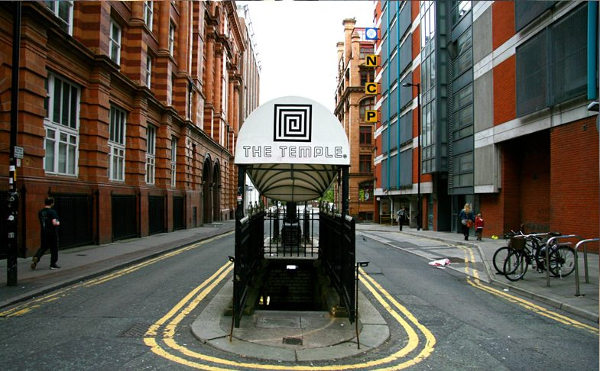

**Café –** If what you are looking for is a place to have some coffee then you’ll be happy to know Manchester has some of these too.

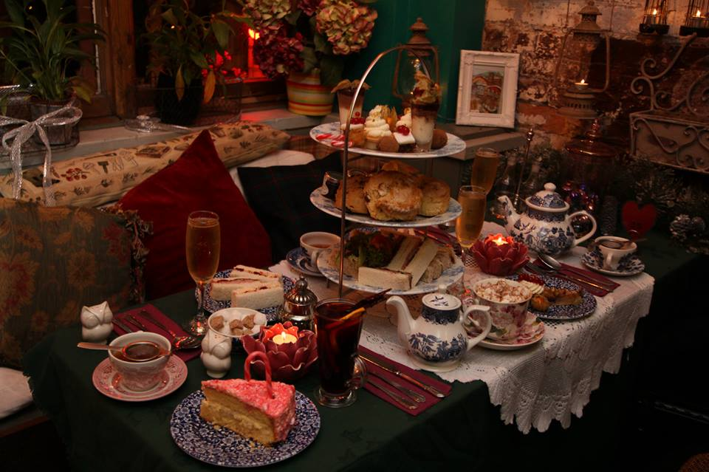

**Restaurant –** Italian, Spanish, Indian, Vegan, Gluten Free – Whatever you want to it, you can find it in Manchester. Sometimes you just have to look for it.

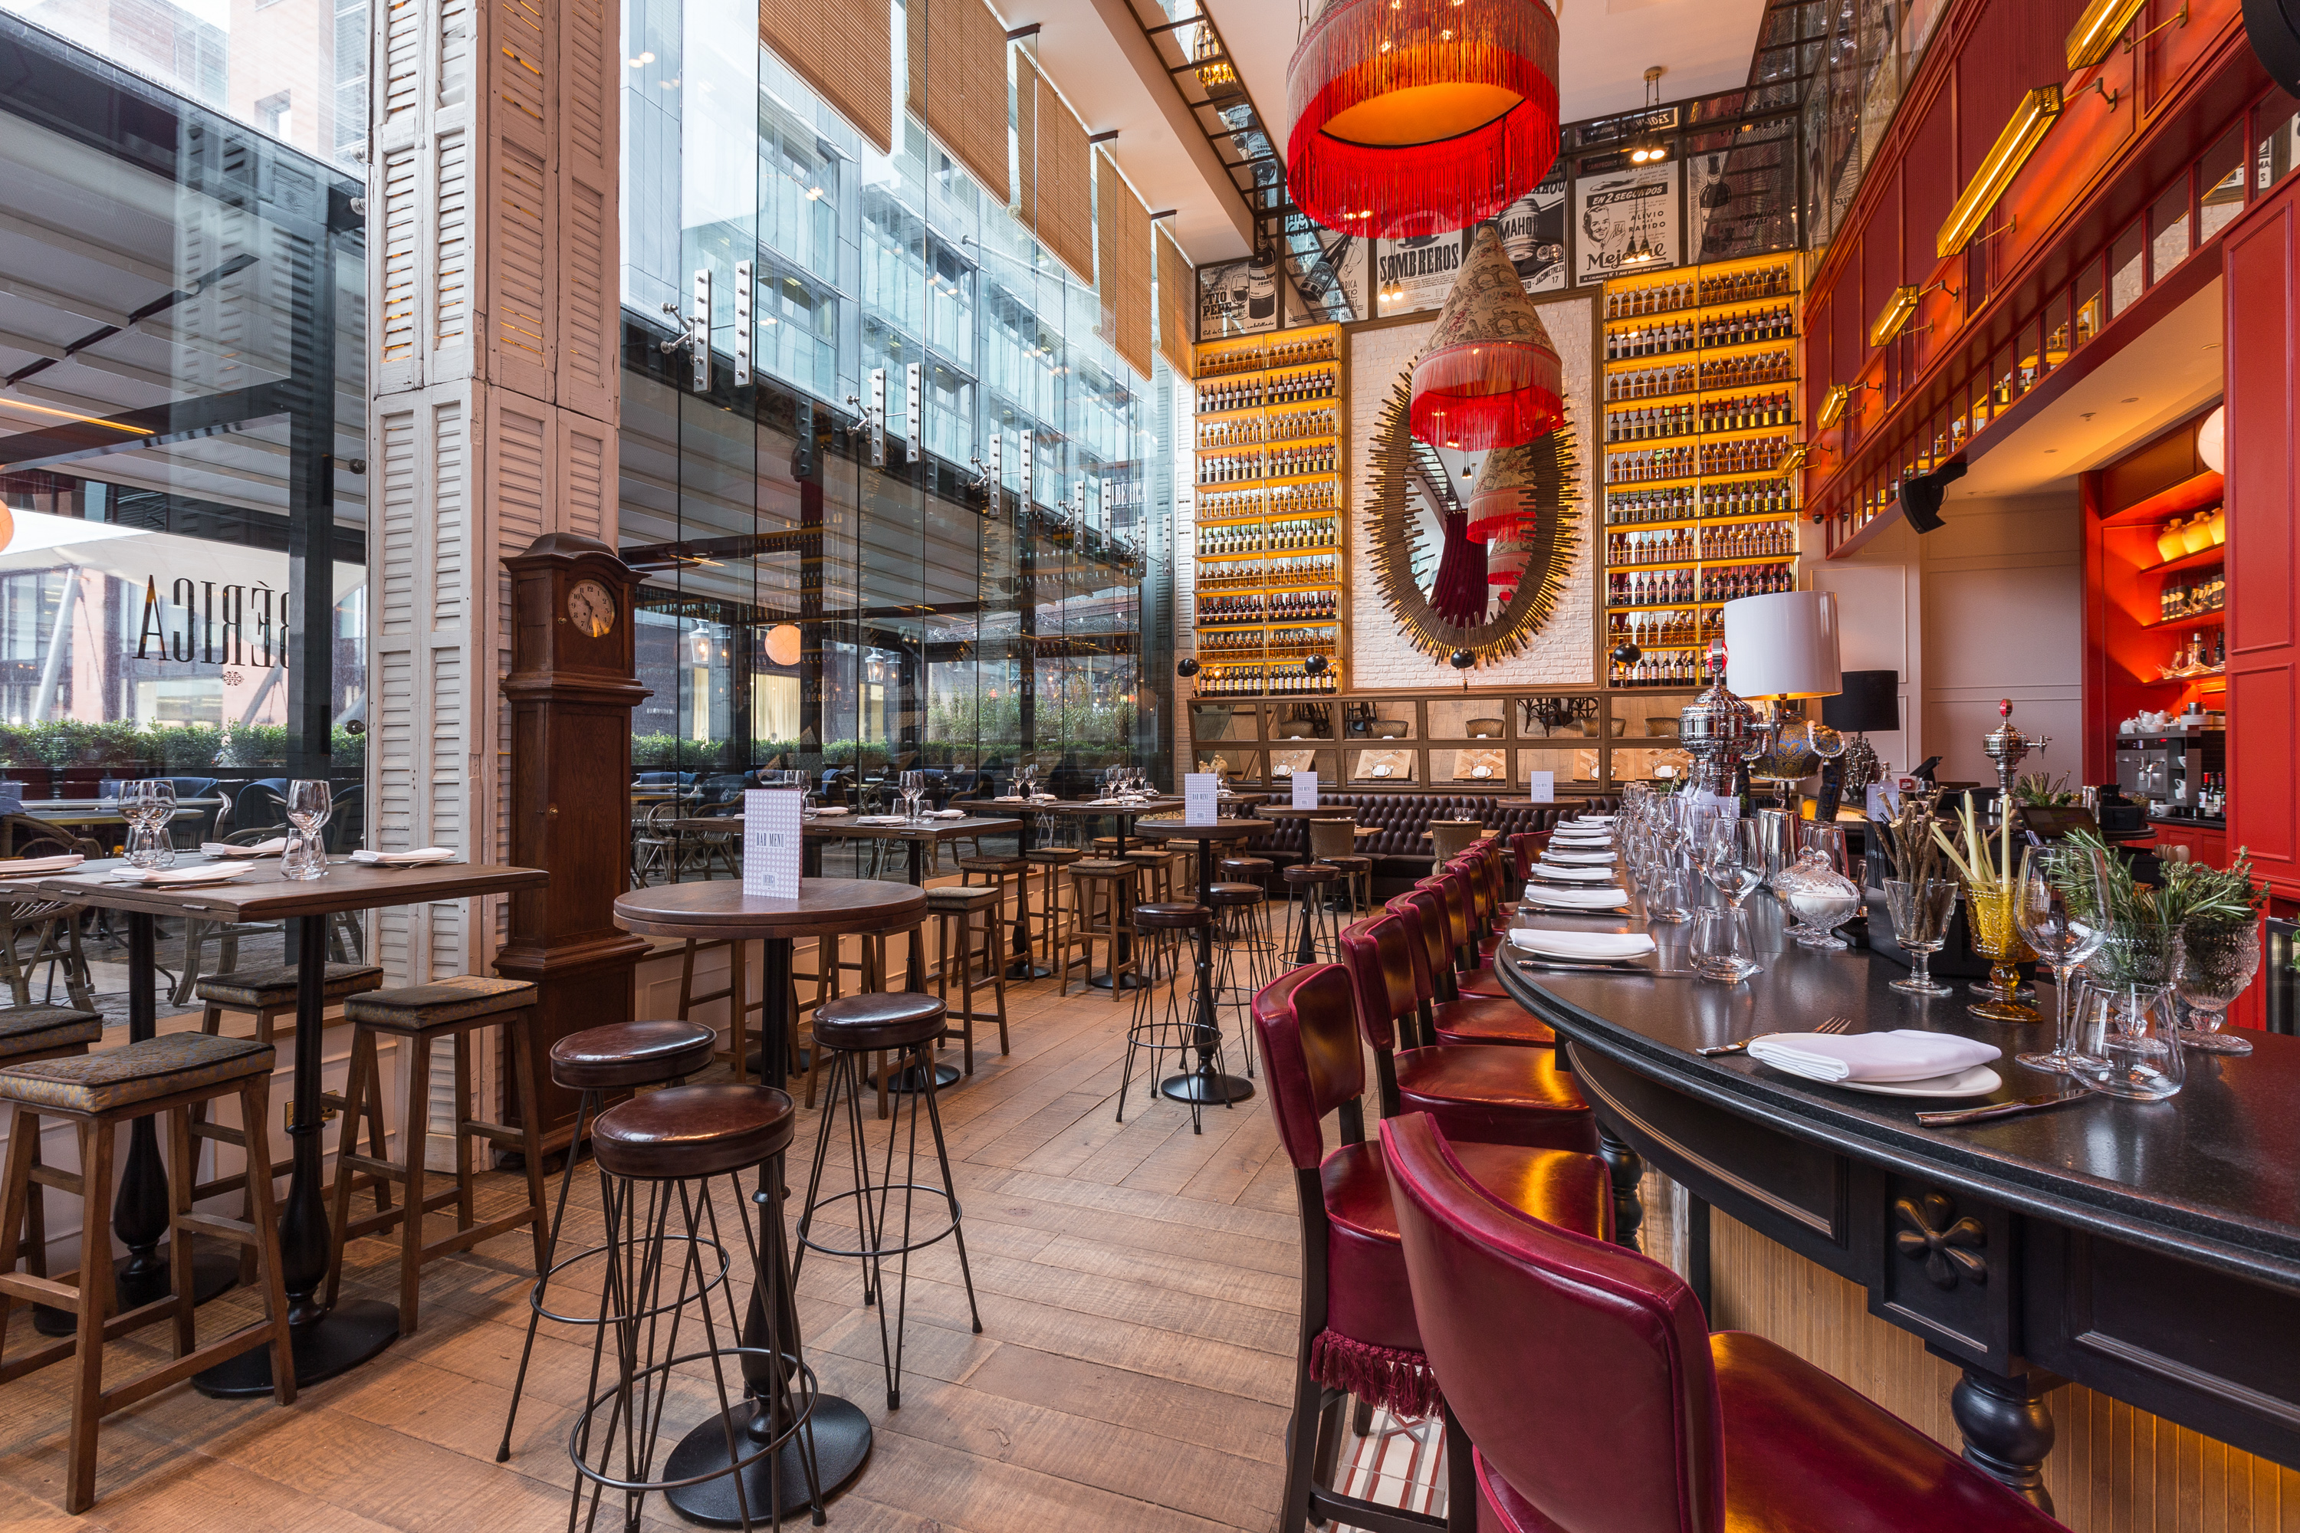

**Shop –** Are you looking for Clothes, Games, or unique hand made items? Doesn’t matter – Manchester has it all!

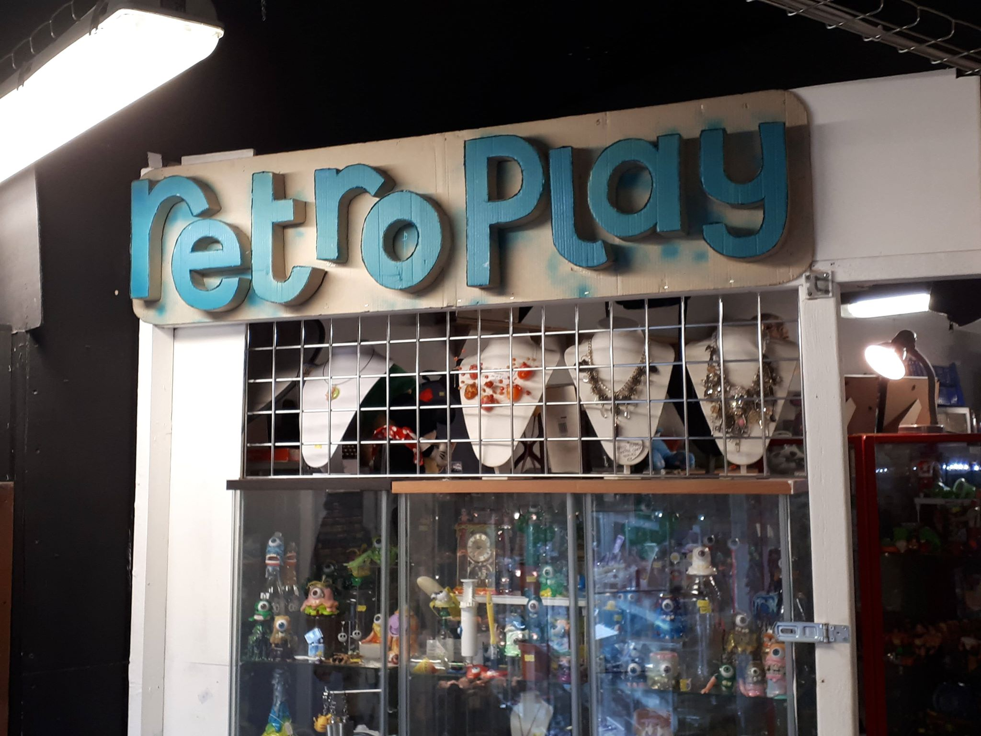

**Night Club –** Manchester aka city that never sleeps. It has been rated top 3 cities in UK for nightlife. And it’s easy to see why.

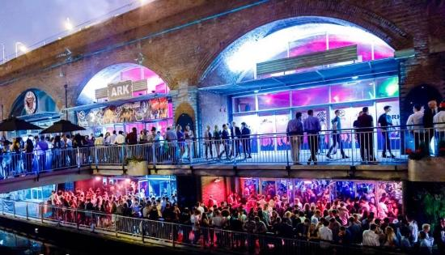

**Entertainment –** Mini Golf, game venues, bowling. There is a lot of place that will entertain you while you are visiting Manchester.

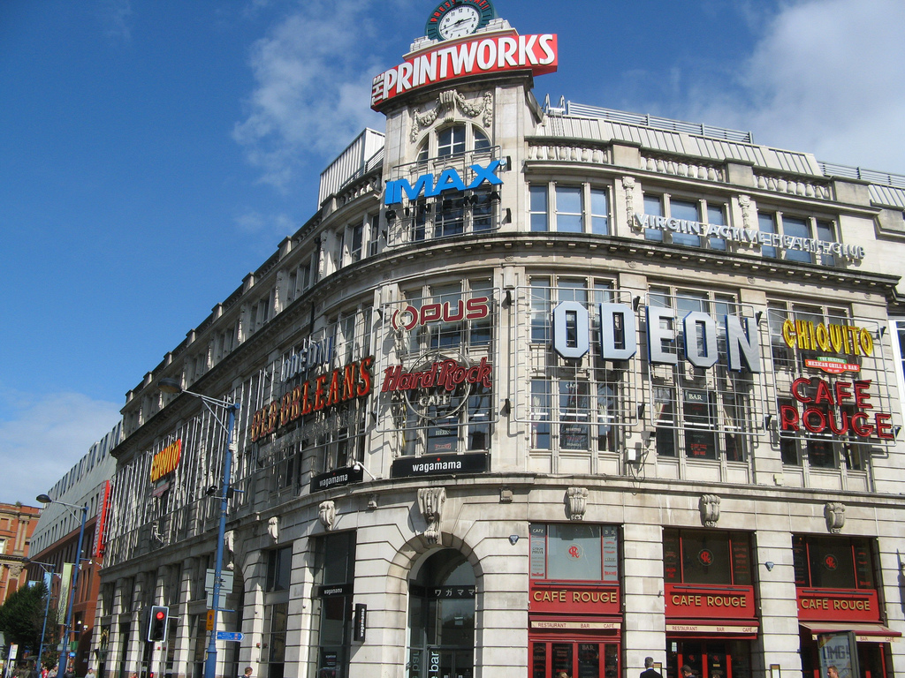

**Touristic –** Manchester has been established as a settlement in about AD 79. This city is soaking in history and touristic places. And we are here to help you find them.

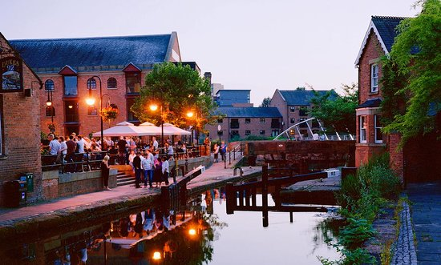

**Shop - Starline Customs:**

Ever wanted to have unique personalised Shoes or clothes? Wait no more - Starline Customs is a little shop based in Manchester’s Northern Quarter. It specialises in creating Hand painted, Custom shoes & clothing. You can find in Affleck’s market, on the third floor. Prices vary, but the minimum you’d have to spend is about £30, and can go up to +£100 – depending how big the artwork is or on what is it painted on. Is being unique worth it? You decide!

**Café - Cat Café:**

One for Cat enthusiasts – Cat Café on High Street, close to printworks. If you ever feel like sipping on a cup of coffee while bunch of cats are everywhere around you – that’s definitely the place for you. Although £12 per person for an hour is a bit pricey, you get unlimited drinks and you get to pet multiple cats (What more do you want from life?). Just remember to book in at least a day in advance, it can get a little bit busy.

**Shop - NotOnYourSkin Engraving:**

Another unique little shop in Affleck’s market in Northern Quarter. In NotOnYourSkin engraving offers a selection of unique glass objects with incredible handmade engraving on them. On top of that you can ask for your own personalised engraving on any type of glass or mirrors you want. So if you want to, you can have a mirror with your face engraved on it, or engrave something personal and give it to someone as a gift. Bit pricey though, we are looking at £50-£200 per piece here.

**Gaming/Shop -** **Retro Play:**

Just as the name suggests, Retro Play is a shop in Affleck’s that offers a variety of gaming consoles, games and toys from good old times. Nintendo64? It’s there. Old brick Gameboy? It’s there? Games for 90% of consoles created in the last 40 years? They are probably there. You can also get old posters, action figures, joysticks, pads and many more.

**Pub – The Temple:**

If you every walked through Oxford Street, you most likely looked at the little stairs going underground and thought “Hmm, I wonder what’s inside”. Well if that happened then here is the answer – The Temple. If you go down the stairs that look like entrance to the subway, you will find a tiny pub with moderately cheap drinks, sociable crowd – and most importantly – an amazing atmosphere.

**Night Club – 42s:**You’re not 19 forever, but since you are or you want to feel like it again - go to 42s nightclub. With cheap drinks, loud 80s/90s/00s music and always a lively crowd this this place will make you dance like nobody’s watching. Make sure you bring cash with you though, entrance can cost you up to £6 and last time I checked you can’t pay for it card.

**Touristic – Vimto:**

I bet at some point in your life you dropped everything, sat down on the floor and thought to yourself – “I wonder where Vimto was created… and by whom”. Luckily for you there’s a massive Vimto statue that that provide you with that information. It is placed right next to Manchester University and Piccadilly Train Station so you can come visit on the way to university or work. Believe me, your life will never be the same after seeing it.

**Entertainment – Dog Bowl:**

Cheap burgers, cheap drinks, and cheap bowling. There is no better way to describe this place. Placed right next to o2 Ritz, both universities and many nightclubs it is an excellent place to kill some time while on uni break or waiting for a gig. If you are a student – remember to bring your ID gard – Each game will cost you 50% less, which last time it was £3 per person.